

**CENTRE FOR DEVELOPMENT OF ADVANCED COMPUTING,**

**IACSD,Pune**

Documentation On

E-Commerce (The Online Shopping Mart)

PG-DAC SEPT 2022

**Prepared by:-**

#### PRN No. Name

#### 230341220100 Mohit Bijwar

#### 230341220150 Rushikesh Mohite

**Project Guide**

**Mr. Narendra Pawar**

**PG DIPLOMA IN ADVANCED COMPUTING**

**C-DAC, IACSD,Pune**

# ABSTRACT

##### This project is a web-based shopping system for an existing shop. The project objective is to deliver the online shopping application into web platform.

This project is an attempt to provide the advantages of online shopping to customers of a real shop. It helps buying the products in the shop anywhere through internet by using a website device. Thus, the customer will get the service of online shopping and home delivery from his favourite shop. This system can be implemented to any shop in the locality or to multinational branded shops having retail outlet chains.

If shops are providing an online portal where their customers can enjoy easy shopping from anywhere, the shops won’t be losing any more customers to the trending online shops such as Amazon, Flipkart or e-bay which are growing in online market. Since this application will be available in the Smartphone as well as on desktops also it is easily accessible and always available from anywhere and on any device having internet accessibility.

# ACKNOWLEDGEMENT

I take this occasion to thank God, almighty for blessing us with his grace and taking our endeavor to a successful culmination. I extend my sincere and heartfelt thanks to our esteemed guide, **Mr. Narendra Pawar** for providing me with the right guidance and advice at the crucial juncture sand for showing me the right way. I extend my sincere thanks to our respected Centre Co-Ordinator **Mr. Rohit sir**, for allowing us to use the facilities available. I would like to thank the other faculty members also, at this occasion. Last but not the least, I would like to thank my friends and family for the support and encouragement they have given me during the course of our work.

**Mohit Bijwar (230341220100)**

**Rushikesh Mohite (230341220150)**

**Table of Contents**

**ABSTRACT 2**

**ACKNOWLEDGEMENT 3**

**INTRODUCTION 6**

* 1. **PROJECT OBJECTIVE 7**
  2. **PROJECT OVERVIEW 7**
  3. **PROJECT SCOPE 8**
  4. **STUDY OF THE SYSTEM. 9**
     1. **MODULES 9**

**SYYSTEM ANALYSIS 12**

* 1. **EXISTING SYSTEM 12**
  2. **PROPOSED SYSTEM 12**
  3. **SYSTEM REQUIREMENT SPECIFICATION 12**

**2.3.2 SYSTEM OBJECTIVES 13**

**2.3.1 SYSTEM REQUIREMENTS 13**

**DESCRIPTION OF FEATURES 14**

**ADMIN 15**

**SYSTEM DESIGN 15**

* 1. **INPUT AND OUTPUT DESIGN 16**
     1. **INPUT DESIGN 16**
     2. **OUTPUT DESIGN 16**

**DATABASES DESIGN 16**

* 1. **DATABASE 16**
  2. **SYSTEM TOOLS… 16**
     1. **FRONT END 17**
     2. **BACKEND 17**

**E-R DIAGRAM… 20**

**CLASS DIAGRAM… 21**

**TABLE STRUCTURE 22**

**PROJECT DIAGRAMS… 25**

**CONCLUSION 37**

**REFERENCES… 38**

# LIST OF FIGURES

FIGURE 1: ADMIN ACTIVITY DIAGRAM 9

2: SELLER ACTIVITY DIAGRAM 10

3: CUSTOMER ACTIVITY DIAGRAM 11

4: SELLER DATA FLOW DIAGRAM 18

5: CUSTOMER DATA FLOW DIAGRAM 19

FIGURE 6: E-R DIAGRAM 20

FIGURE 7: CLASS DIAGRAM 21 FIGURE 8: TABLE STRUCTURE 22 FIGURE 9: PROJECT DIAGRAMS 25

# INTRODUCTION

The purpose of this SRS is to provide a clear, documented model of the requirements for

**E-Commerce** online shopping website. This document serves to provide top level use cases for a web customer making purchases online. The OSM (Online shopping system) system includes the Customer subsystem as well the Seller subsystem.

The OSM provides a platform for conducting sales of a wide variety of goods across the globe. It is implemented as an internet-based enterprise and has a vast inventory of products from books, houseware, electronics, groceries and much more. Sellers use this system to easily expand their service to a more global platform. This guarantees better flexibility, larger audience and an improved market. The appeal of OSM experienced a large boost in the last decade because the customers can browse easily through various options, brands and price ranges with very little hassle. The ability to reap its benefits from the comfort of one’s own home has only bolstered its claim as one of the biggest enterprises that dominates the internet. This project is an attempt to provide the advantage of online shopping to customer of physical store. It helps buying the products in the shop anywhere through internet by using a smart phone, computer. Thus, the customer will get the service of online shopping and home delivery from their favourite shop through E-Commerce OSM.

The document describes the scope, functionality and features of an online shopping system which has a large audience. This document finds relevance to people from various different technical and non-technical backgrounds. The document outlines various corporate goals, business strategies and design features that are important from a management point of view and can be used by project managers. It analyses performance, visibility and brand awareness which is important for marketing and advertising. With detailed analysis of the system design, features, implementation and performance, the document proves highly valuable to developers and testers. Through the rest of the document, one becomes familiarized with the scope of these E-Commerce OSM - from their purpose, benefits and business strategies. The context and origin of the product as well as its basic functionality are then explained in relevant detail along with an analysis of its different classes, design and implementation. We then detail the interface requirements, build analysis models and examine system features and non-functional requirements.

# PROJECT OBJECTIVE

The objective of the project is to make an E-commerce web application in to purchase items in an existing shop. In order to build such an application complete web support, need to be provided. A complete and efficient web application which can provide the online shopping experience is the basic objective of the project. The web application can be implemented in the form of an e-commerce application with web view.

# PROJECT OVERVIEW

This system provides an easy solution for customers to buy the product without going to the shop and also to shop owner to sale the product. This proposed system can be used by any naive users and it does not require any educational level, experience or technical expertise in computer field but it will be of good use if user has the good knowledge of how to operate a computer and smart phone.

The E-Commerce OSM application enables vendors to set up online shops, customers to browse through the shops, and a system administrator to approve and reject requests for new shops and maintain lists of shop categories. Also, the developer is designing an online shopping site to manage the items in the shop and also help customers to purchase them online without visiting the shop physically. The E- Commerce OSM will use the internet as the sole method for selling goods to its consumers.

##### Product Perspective

This product aimed toward a person who don’t want to visit the shop as he might don’t get time for that or might not interested in visiting there and dealing with lot of formalities.

##### Product Function

E-Commerce OSM should support this use case:

##### User Characteristics

User should be familiar with the terms like login, register, Cart, order, Payment modes etc.

##### Principle Actors

3 Principal Actors are Admin, Customer and Seller.

##### General Constraints & Dependencies

Working of E-Commerce OSM will require Smart Phone or Computer with full internet connection.

# PROJECT SCOPE

The E-Commerce OSM provides a platform for conducting sales of a wide variety of goods and provides a way of bringing sellers and customers on an online platform to conduct transactions in a secure manner across the globe. It is implemented as an online enterprise. This system provides an avenue for customers to shop from a wide variety of products online. It also provides sellers a platform where they can upload their listing to the system for customers to view and purchase. The biggest advantages of the service is the comfort it brings with remote usage. The ability to compare various price ranges, brands and even customer reviews and experiences provides for a more honest/depth understanding of the product. It also provides a platform for retailers and sellers to reach a global audience.

Fitted with recommendation models to analyse customer interests, previous purchases and ratings can help recommend other products that the customer may like. This model is essential to increase visibility of useful products to the customer but also to boost the service’s revenue. The service also has a large database that stores customer data and history. Another important benefit provided by the service is the reviews section. The reviews section offers transparency around product performance and user experience. Not only do items have ratings given to it by users, but also detailed user reviews with an option to attach pictures of the product. This feature boosts customer trust and creates a community of customers who can engage with each other and help one another select the right products. A key feature is secure money transaction along with guaranteed and time bound product delivery.

Increasing sales is of the highest priority to the E-Commerce OSM. Turnover can increase only with an increase in sales. Various strategies need to be tested to find suitable growth strategies for the business. Minimizing management costs, customer loyalty and retention and customer satisfaction are essential corporate goals that are important to boost sales. A huge part of the business strategy is using the internet and its various resources to its advantage from technological innovation, marketing strategy and business model. Continuous and adaptive research and development with a focus on logistics is essential for business growth. Besides M&A, investments and strategic partnerships, another way to expand business is to invest in emerging markets and new businesses. The vision of the E-Commerce is to be able to provide a smooth and user-friendly platform for customers to select from a wide range of products conveniently and to cater to the needs of both customers and sellers.

# STUDY OF THE SYSTEM

## MODULES:

The system after careful analysis has been identified to be presented with the following modules and roles.

##### The modules involved are:

* Administrator

##### Supplier

* Users

**Administrator:**

The administrator is the super user of this application. Only admin have access into this admin page. Admin may be the owner of the shop. The administrator has all the information about the users and about all products.

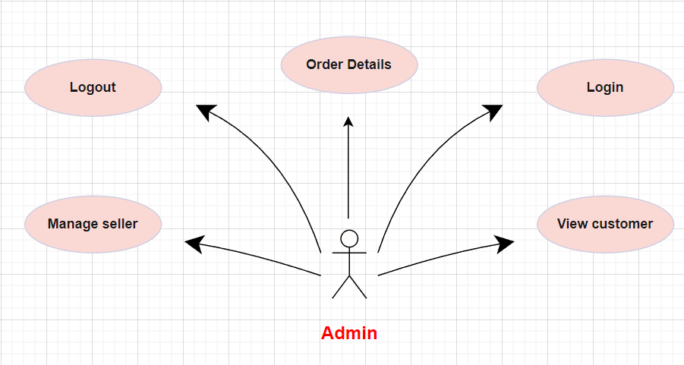

##### Figure 1: Admin Activity Diagram

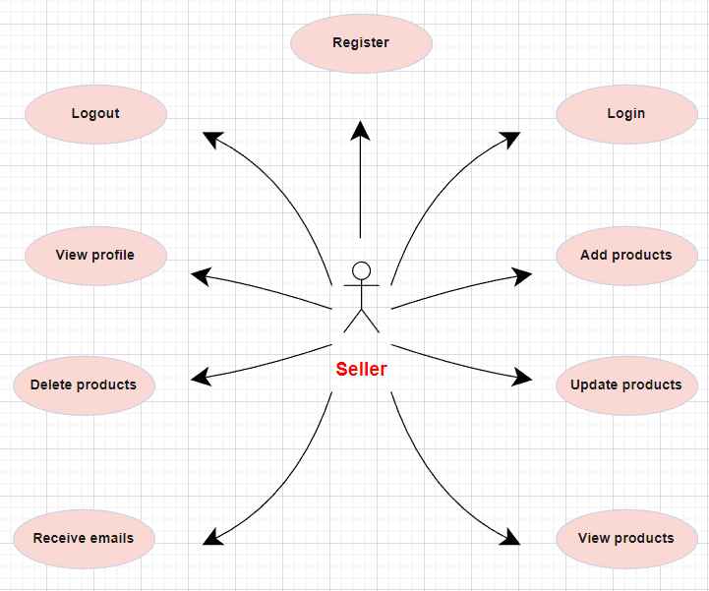

Figure 2: Seller Activity Diagram

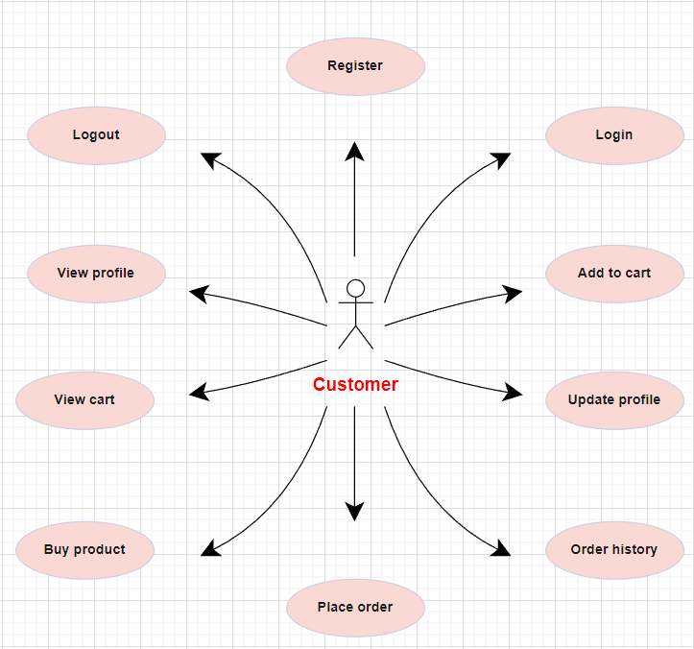

Figure 3: Costumer Activity Diagram

# 2.0 SYSTEM ANALYSIS

System analysis is the process of gathering and interpreting facts, diagnosing problems, and using the information to recommend improvements on the system. System analysis is a problem-solving activity that requires intensive communication between the system users and system developers. System analysis or study is an important phase of any system development process. The system is viewed as a whole, the inputs are identified, and the system is subjected to close study to identify the problem areas. The solutions are given as a proposal. The proposal is reviewed on user request and suitable changes are made. This loop ends as soon as the user is satisfied with the proposal.

## EXISTING SYSTEM

The current system for shopping is to visit the shop manually and from the available product choose the item customer want and buying the item by payment of the price of the item.

* + - It is less user-friendly.
    - User must go to shop and select products.
    - It is difficult to identify the required product.
    - Description of the product limited.
    - It is a time-consuming process
    - Not in reach of distant users.

## PROPOSED SYSTEM

In the proposed system customer need not go to the shop for buying the products. They can order the product they wish to buy through the web application by just clicking some buttons and from their own place. The shop owner will be seller on the system. Shop owner can appoint moderators who will help owner in managing the customers and product orders.

# SYSTEM REQUIREMENT SPECIFICATION

As online shopping became a trend nowadays the regular shops are losing their customers to online brands. Customers have effortless shopping experience and saving time through shopping online. For competing with those online brands, if shops are providing an online portal where their customers can shop through internet and get the products at their doors it will increase the number of customers.

## SYSTEM OBJECTIVES

* To provide a Web application for online shopping of products in an existing shop.
* To provide an online shopping web site for the same shop.

## SYSTEM REQUIREMENTS

#### NON-FUNCTIONAL REQUIREMENTS

Modularity:

* OSM would be complex application due to its functionality expected.
* OSM would be composed using set of reusable modules.

Portability:

* OSM could be accessed from any personal device.
* OSM will provide portable user interface using standard web technologies while building portal.
* OSM could be deployed to any server Operating Environment.
* OSM could be deployed to any Cloud such as Microsoft Azure or Amazon Web Service (AWS) or GCP
* OSM could have been deployed to any other physical server or Virtualized server.

Security:

* OSM will implement Role based security to access content from Remote place.
* OSM will provide secure communication between payment gateway applications (SSL)
* OSM will expire session maintained for each user after 15 minutes.
* OSM will not keep any sensitive data on user’s device.
* Users’ information would be protected.
* All servers where OSM deployed would have been protected using firewall.

Safe:

* OSM will keep regular back up of data in incremental way.
* OSM will be protected against malicious attack with proper cybersecurity rules.
* OSM hosted servers would have been protected within restricted environment.

Reliability:

* OSM will always be available 99.999%
* OSM should have low downtime
* OSM server would keep their availability using failover server

Scalability:

* OSM will provide consistent user experience irrespective of number users grow on particular events such as festival season, Sale promotion. (Load balancing).

Compatibility:

* OSM could be installed on Windows server, Linux server.
* OSM will provide chrome browser compatible user interface.

#### FUNCTIONAL REQUIREMENTS

###### USER

* + USER LOGIN

**Description of feature**

This feature used by the user to login into system. A user must login with his username and password to the system after registration. If they are invalid, the user not allowed to enter the system.

Functional Requirement

* Username and password will be provided after user registration is confirmed.
* Password should be hidden from others while typing it in the field.
  + REGISTER NEW USER

###### Description of feature

A new user will have to register in the system by providing essential details in order to view the products in the system. The admin must accept new user by unblocking him.

Functional Requirement

* System must be able to verify and validate information.
* The system must encrypt the password of the customer to provide security.
  + PURCHASING AN ITEM

###### Description of feature

The user can add the desired product into his cart by clicking add to cart option on the product. He can view his cart by clicking on the cart button. All products added by cart can be viewed in the cart. User can remove an item from the cart by clicking remove. After confirming the items in the cart, the user can submit the cart by providing a delivery address. On successful submitting the cart will become empty.

Functional Requirement

* + - System must ensure that, only a registered customer can purchase items.
    - Admin account should be secured so that only owner of the shop can access that account.

###### ADMIN

* MANAGE USER

###### Description of features

The administrator can add user, delete user, view user and block user.

* VIEW ORDER

###### Description of features

The administrator can view orders and orders details of customers. Functional Requirements:

* The system must identify the login of the admin.
* Admin account should be secured so that only owner of the shop can access that account.

# SYSTEM DESIGN

System design is the solution for the creation of a new system. This phase focuses on the detailed implementation of the feasible system. Its emphasis on translating design.

Specifications to performance specification. System design has two phases of development.

* Logical Design
* Physical Design

During logical design phase the analyst describes inputs (sources), outputs(destinations), databases (data sores) and procedures (data flows) all in a format that meets the user requirements. The analyst also specifies the needs of the user at a level that virtually determines the information flow in and out of the system and the data resources. Here the logical design is done through data flow diagrams and database design. The physical design is followed by physical design or coding. Physical design produces the working system by defining the design specifications, which specify exactly what the candidate system must do. The programmers write the necessary programs that accept input from the user, perform necessary processing on accepted data and produce the required report on a hard copy or display it on the screen.

## INPUT AND OUTPUT DESIGN

##### INPUT DESIGN:

Input design is the link that ties the information system into the world of its users. The input design involves determining the inputs, validating the data, minimizing the data entry and provides a multi-user facility. Inaccurate inputs are the most common cause of errors in data processing. Errors entered by the data entry operators can be controlled by input design. The user-originated inputs are converted to a computer-based format in the input design. Input data are collected and organized into groups of similar data. Once identified, the appropriate input media are selected for processing. All the input data are validated and if any data violates any conditions, the user is warned by a message. If the data satisfies all the conditions, it is transferred to the appropriate tables in the database. In this project the student details are to be entered at the time of registration. A page is designed for this purpose which is user friendly and easy to use. The design is done such that users get appropriate messages when exceptions occur.

##### OUTPUT DESIGN:

Computer output is the most important and direct source of information to the user. Output design is a very important phase since the output needs to be in an efficient manner. Efficient and intelligible output design improves the system relationship with the user and helps in decision making. Allowing the user to view the sample screen is important because the user is the ultimate judge of the quality of output. The output module of this system is the selected notifications.

# DATABASE DESIGN

## DATABASE

Databases are the storehouses of data used in the software systems. The data is stored in tables inside the database. Several tables are created for the manipulation of the data for the system. Two essential settings for a database are -

* Primary key - the field that is unique for all the record occurrences
* Foreign key - the field used to set relation between tables Normalization is a technique to avoid redundancy in the tables.

## SYSTEM TOOLS

The various system tools that have been used in developing both the front end and the back end of the project are being discussed in this chapter.

#### FRONT END:

React is a library which is developed by Facebook are utilized to implement the frontend. React (also known as React.js or ReactJS) is a free and open-source front-end JavaScript library for building user interfaces or UI components. It is maintained by Facebook and a community of individual developers and companies. React can be used as a base in the development of single page or mobile applications. However, React is only concerned with state management and rendering that state to the DOM, so creating React applications usually requires the use of additional libraries for routing, as well as certain client-side functionality.

#### BACKEND:

The back end is implemented using MySQL which is used to design databases.

**MySQL:**

MySQL is the world's second most widely used open-source relational database management system (RDBMS). The SQL phrase stands for Structured Query Language. An application software called Navicert was used to design the tables in MySQL.

**Spring-Boot:**

This is used to connect MYSQL and fetch data from database and store the data in database. The Spring Framework is an application framework and inversion of control container for the Java platform. The framework's core features can be used by any Java application, but there are extensions for building web applications on top of the Java EE (Enterprise Edition) platform. Although the framework does not impose any specific programming model, it has become popular in the Java community as an addition to the Enterprise JavaBeans (EJB) model. The Spring Framework is Open-source Framework.

#### Seller Data Flow Diagram

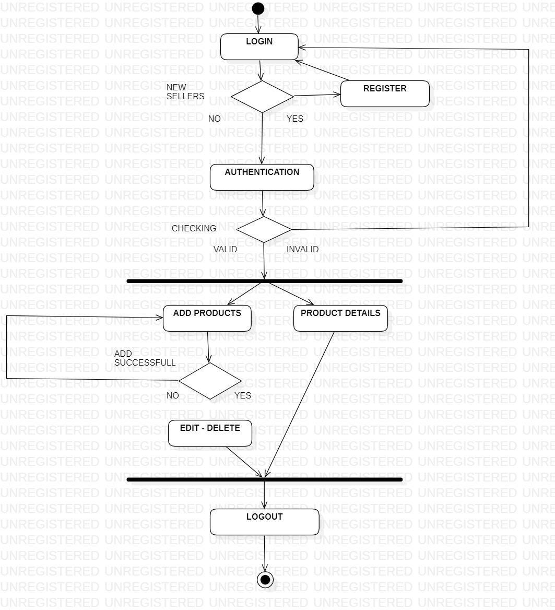

Figure 4: Seller Data Flow Diagram

#### Customer Data Flow Diagram

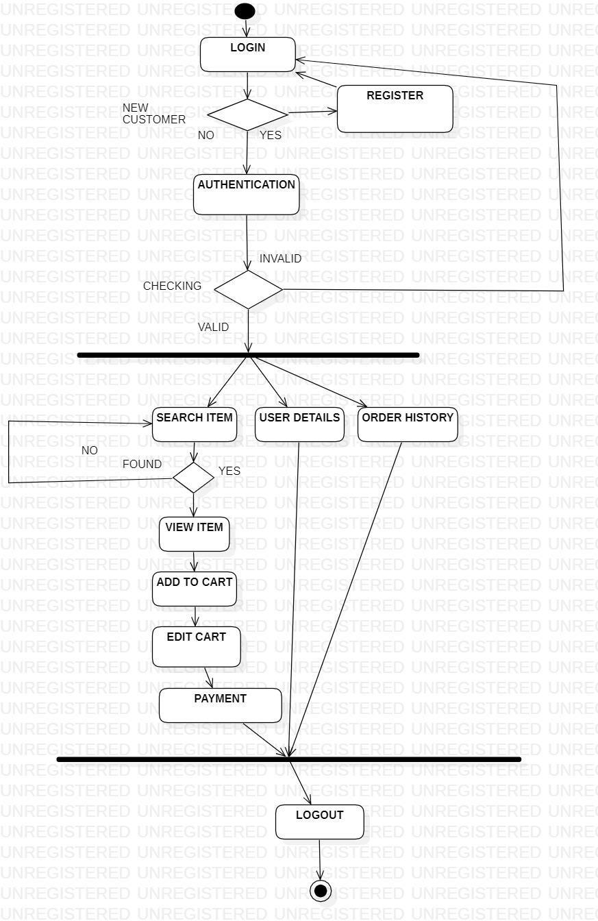

Figure 5: Customer Data Flow Diagram

#### E-R Diagram

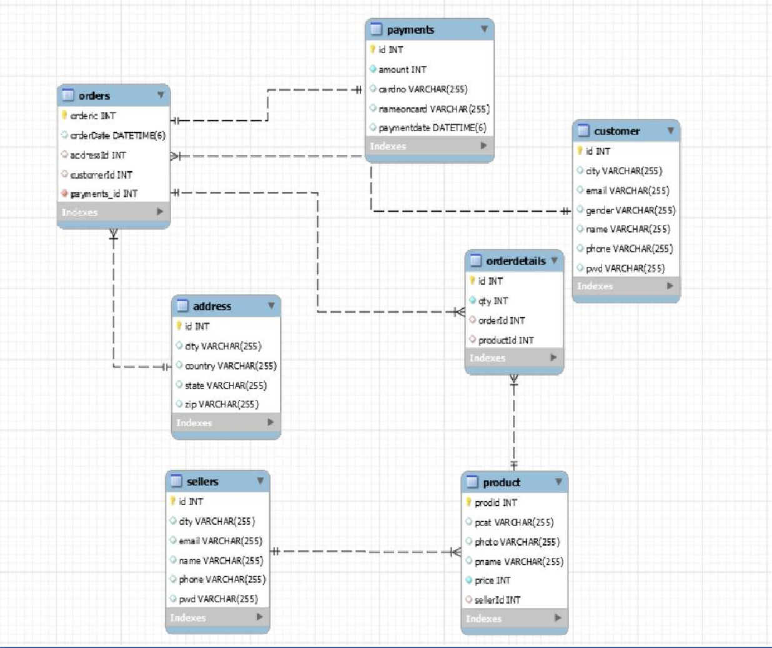

Figure 6: E-R Diagram

#### Class Diagram

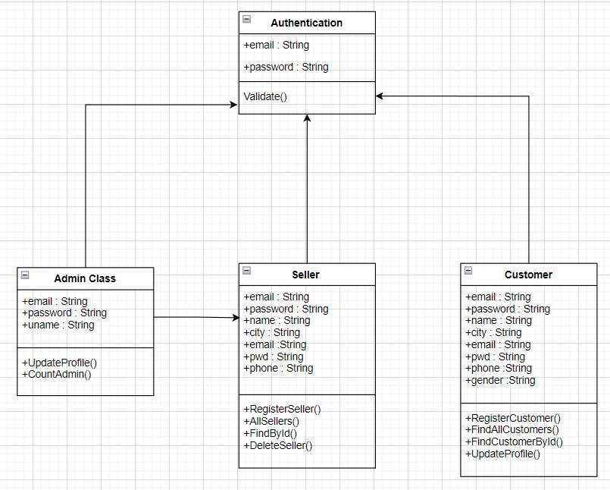

Figure 7: Class Diagram

### Table Structure

#### Tables :

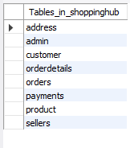

**Admin :**

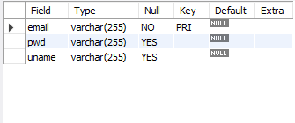

#### Sellers :

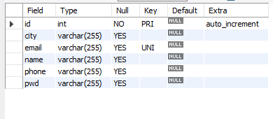

**Products :**

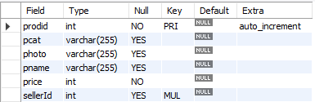

#### Customers :

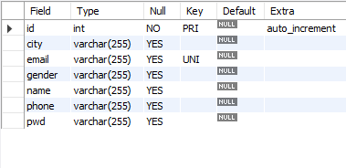

**Address :**

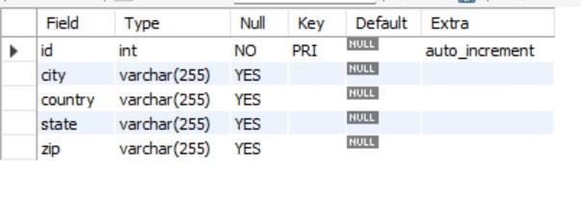

#### Orders :

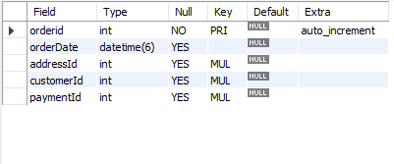

**Order Details :**

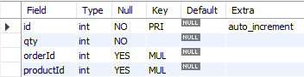

**Payment :**

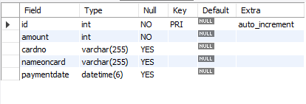

**Project Diagrams**

#### Home page

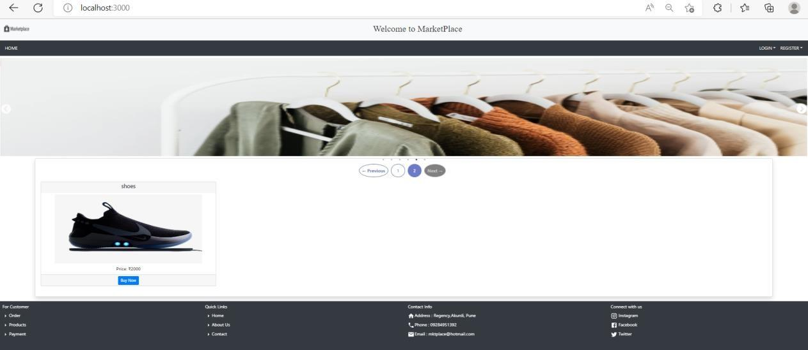

**Seller registration**

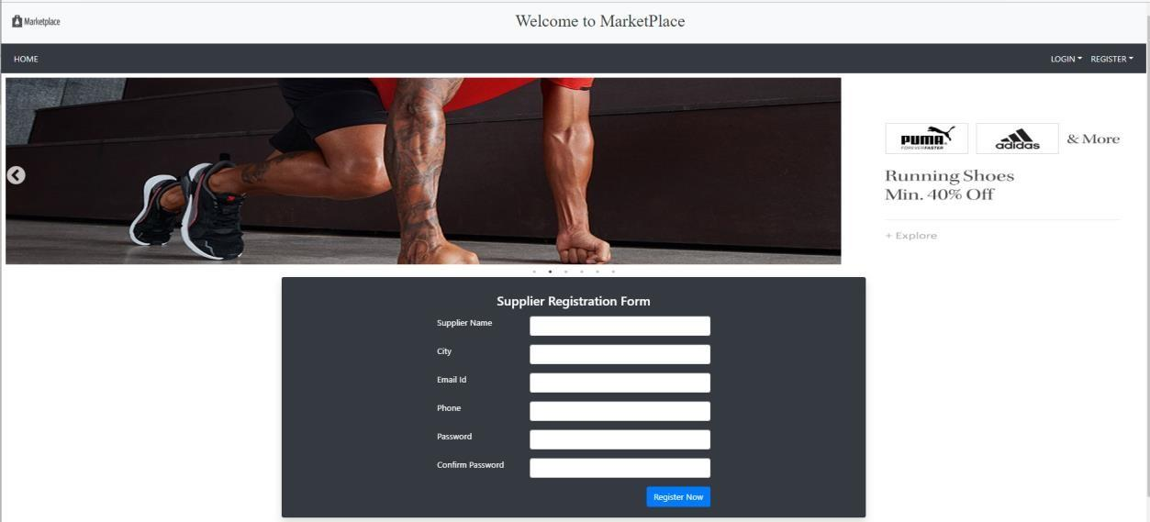

**Seller login details**

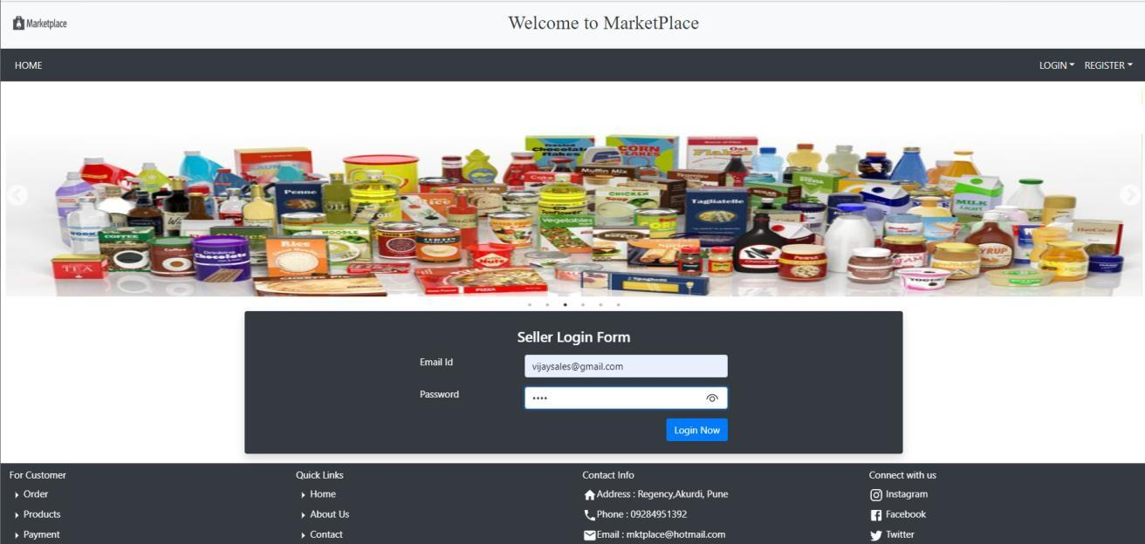

**Seller profile page**

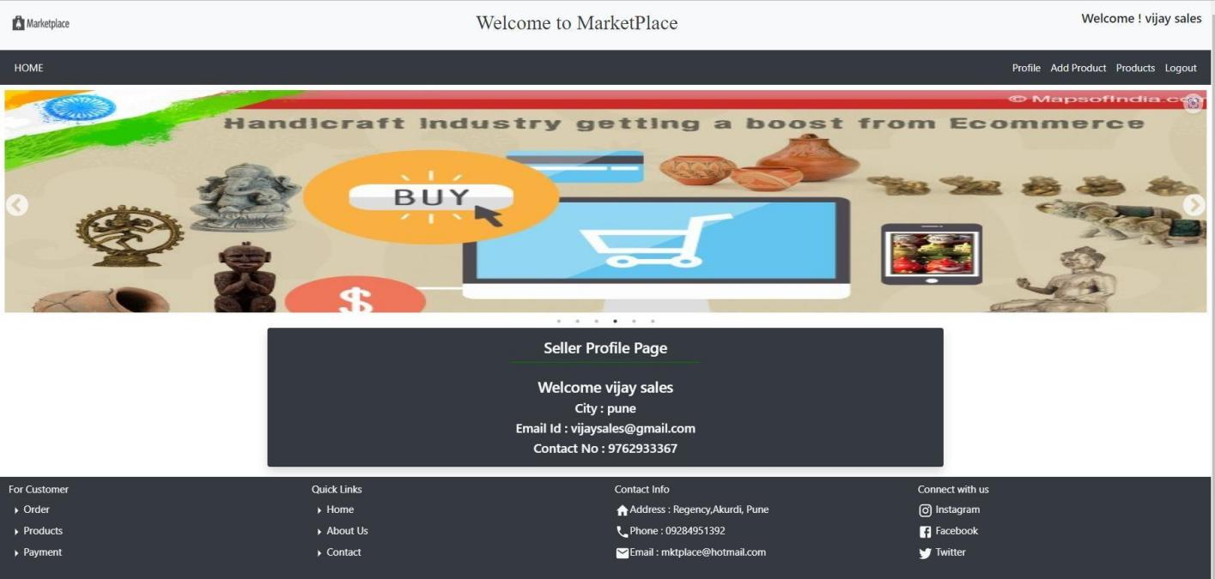

#### Seller add products details form

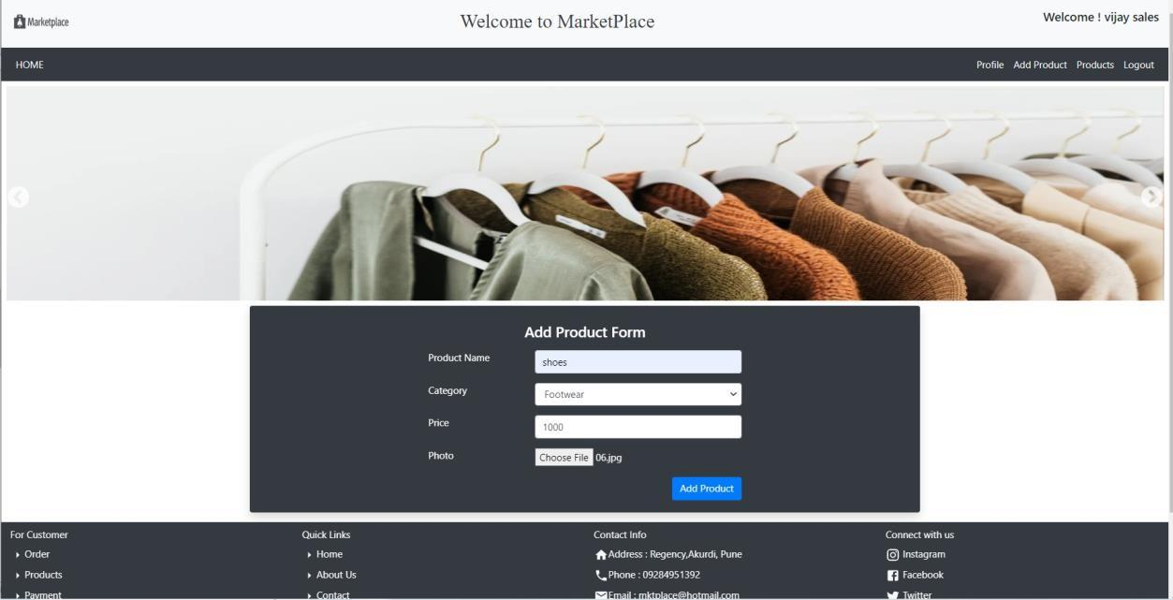

**Seller add product successfully**

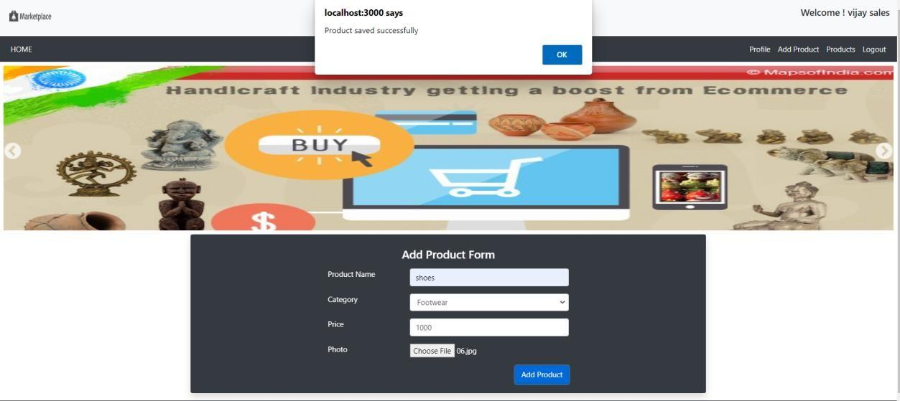

#### Sellers product list

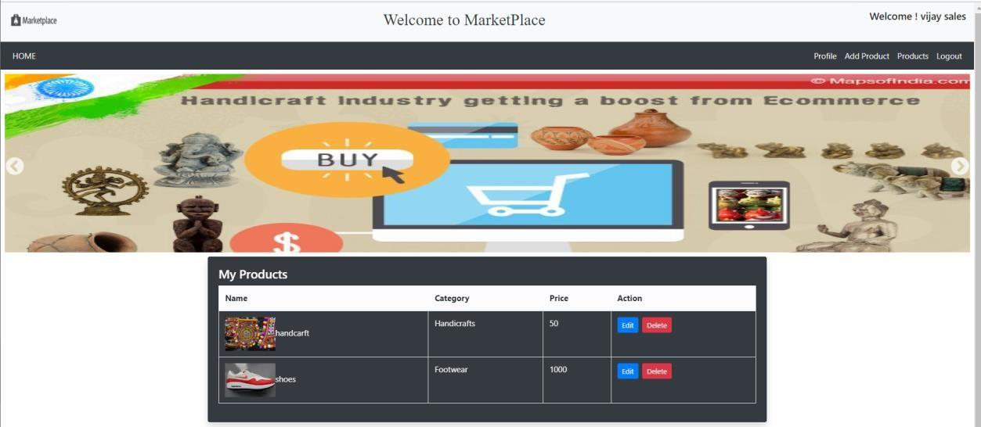

**Seller product updated**

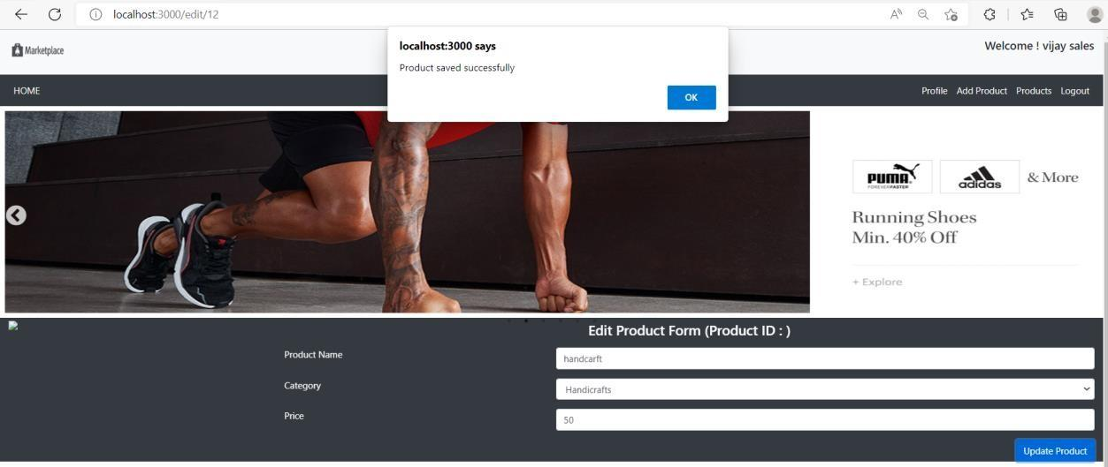

#### Seller product deleted

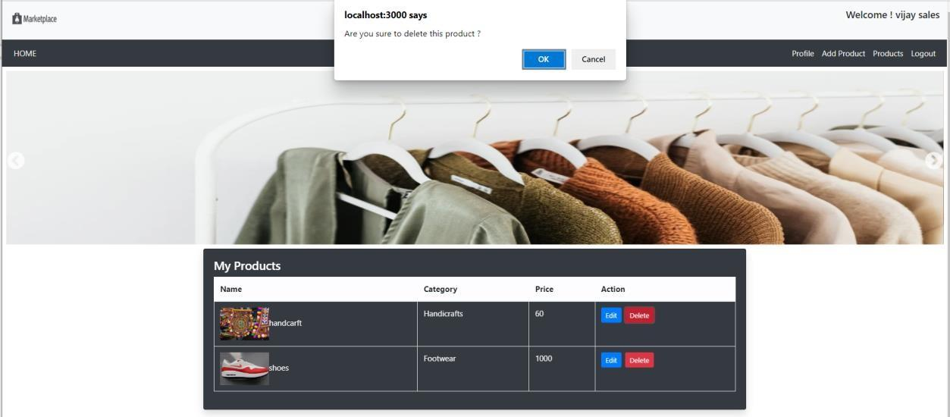

**Customer registration form**

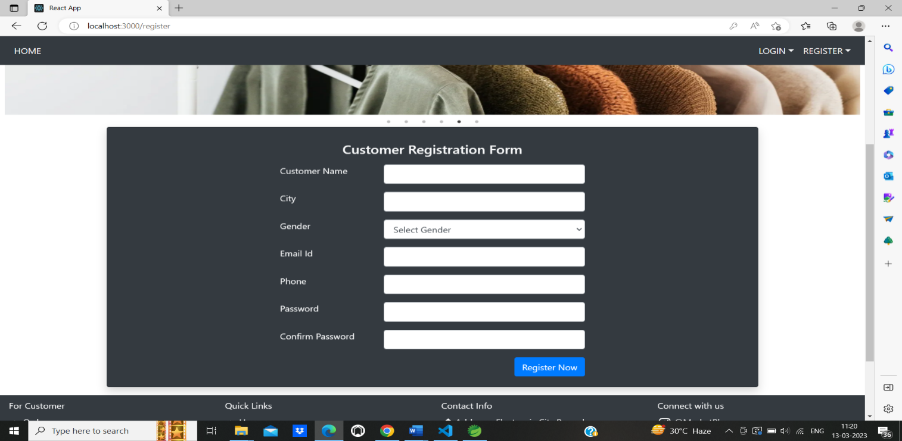

**Customer Login Page**

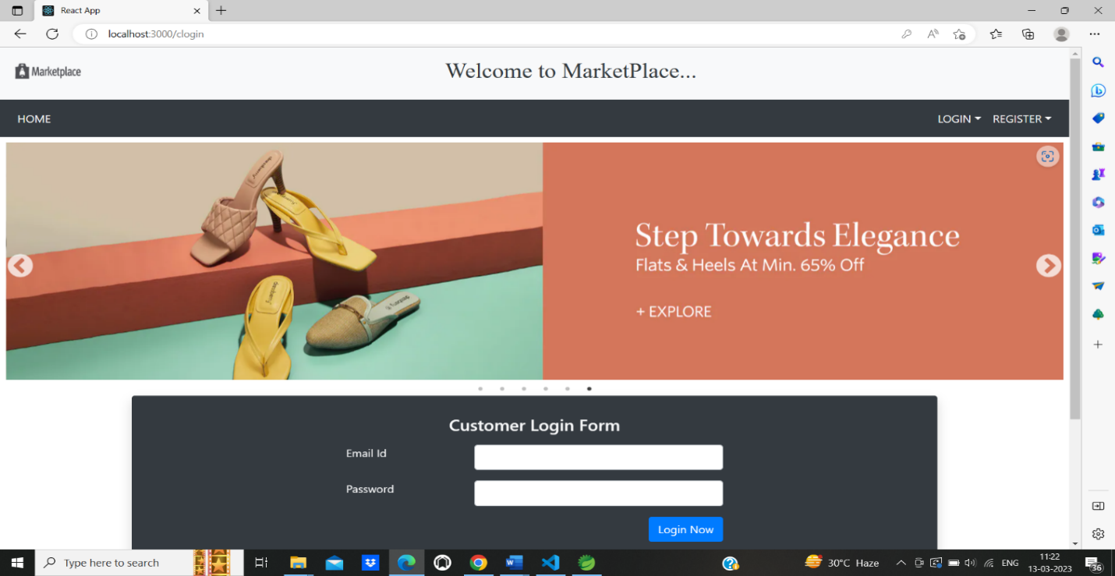

#### After Login Customer Home Page

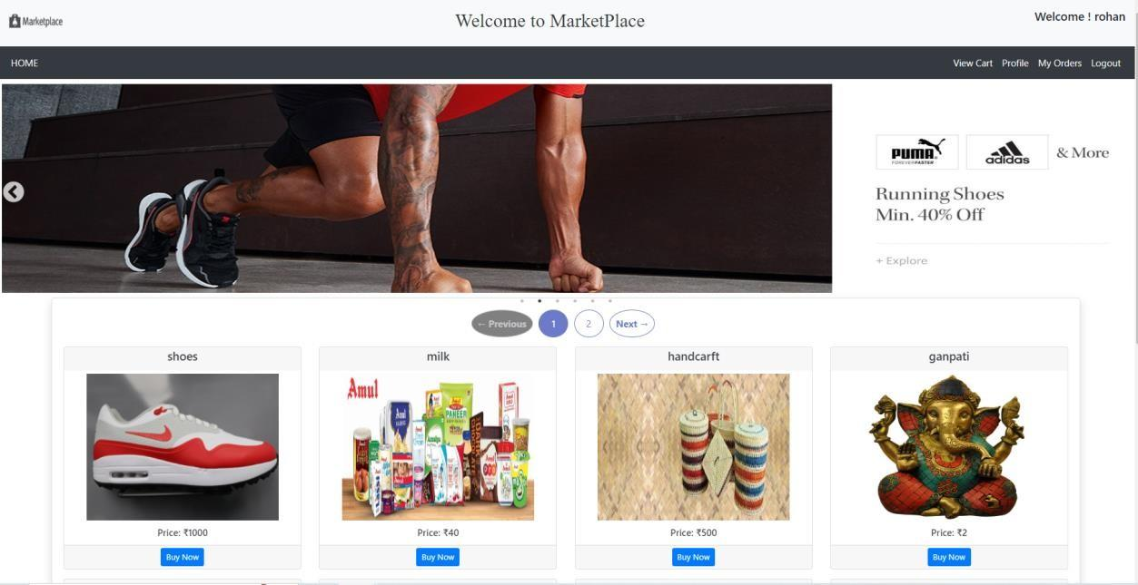

#### Customer View cart page

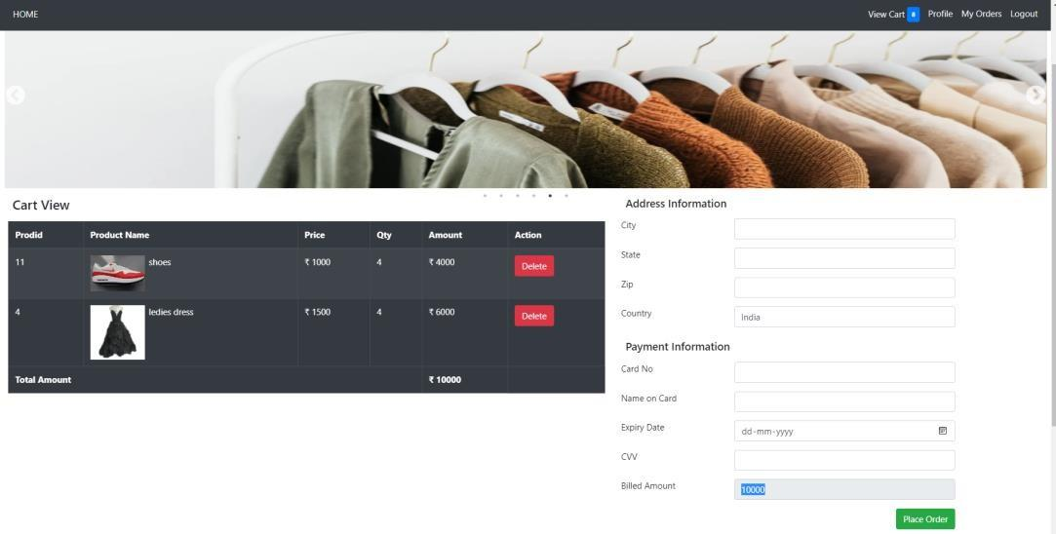

**Customer buy a product**

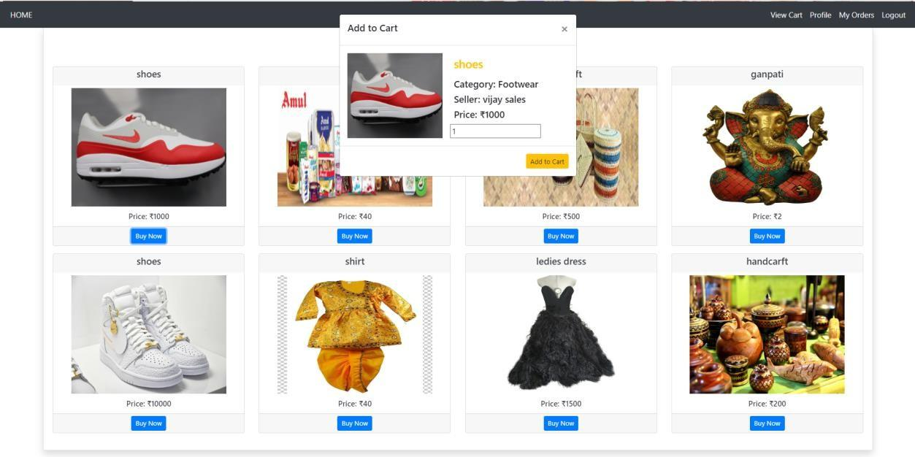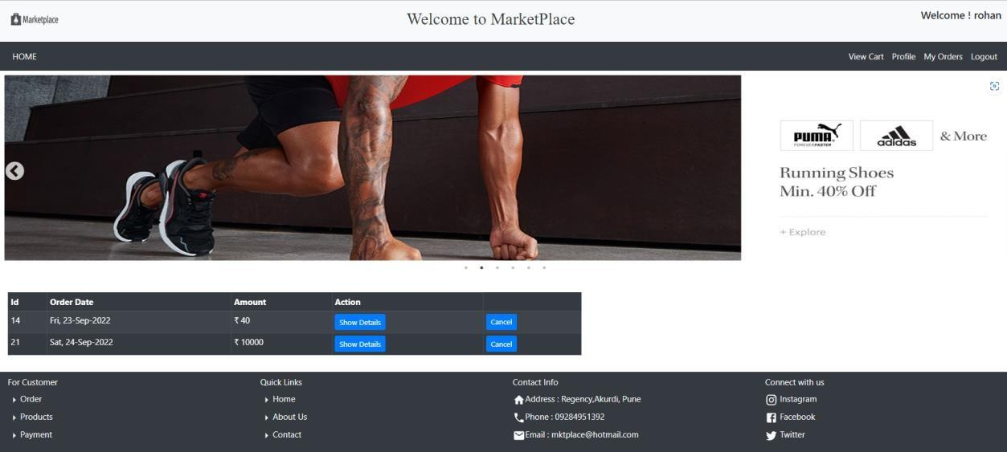

#### Customer’s show the specific product order details

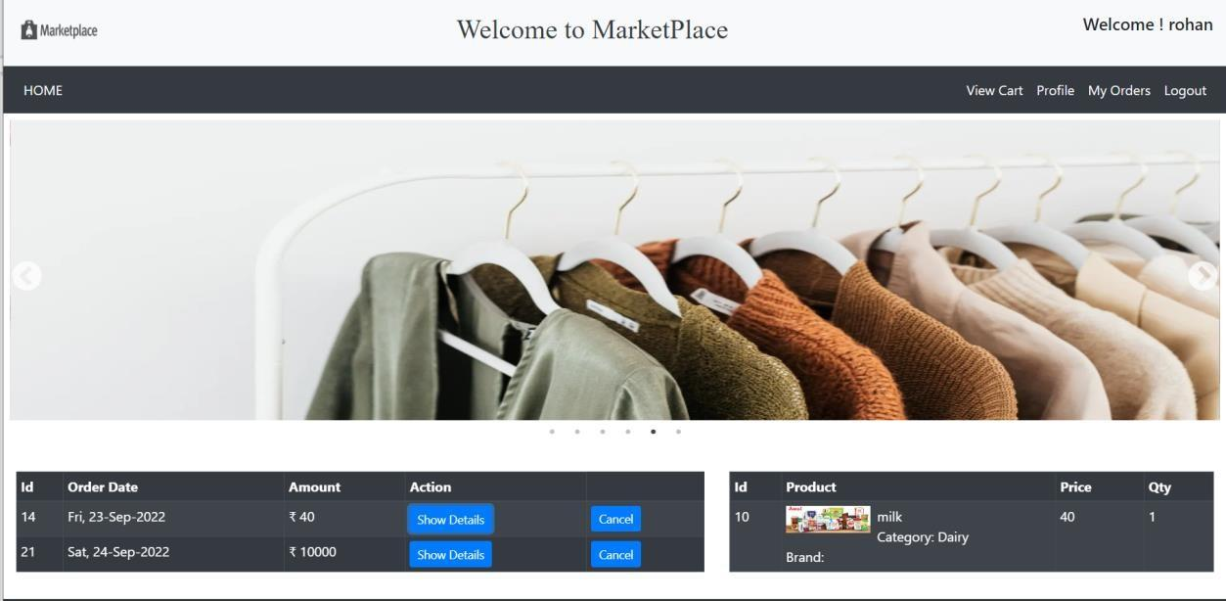

#### Admin login page

#### 

#### Admin show the seller details

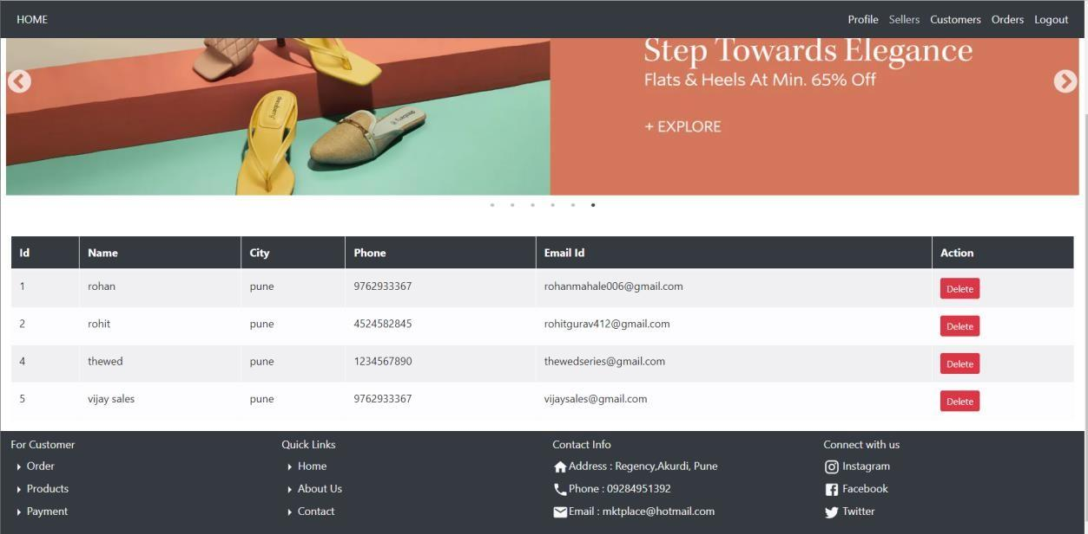

**Admin deleted seller**

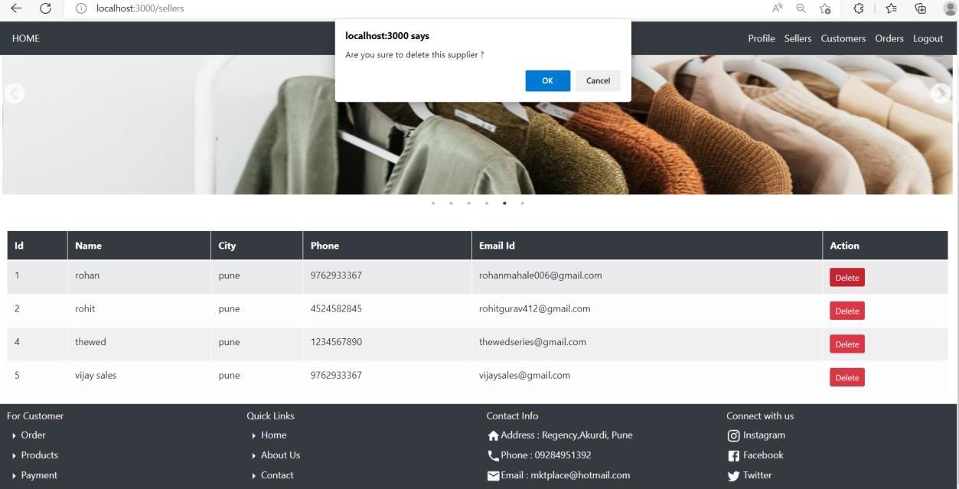

#### Admin view the all customers details

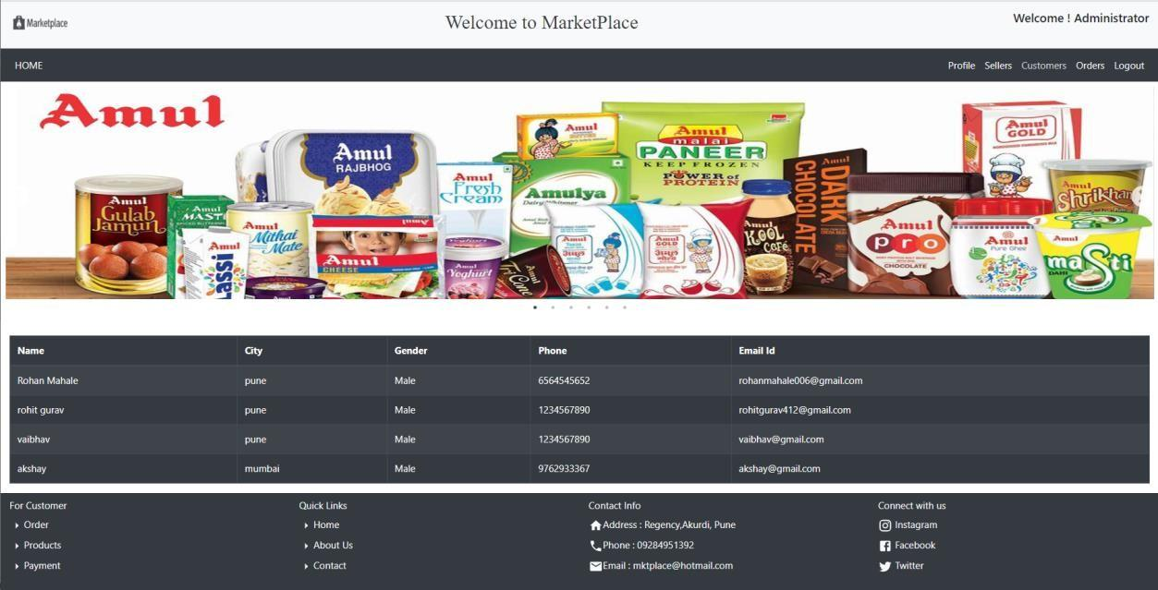

**Admin view the total orders**

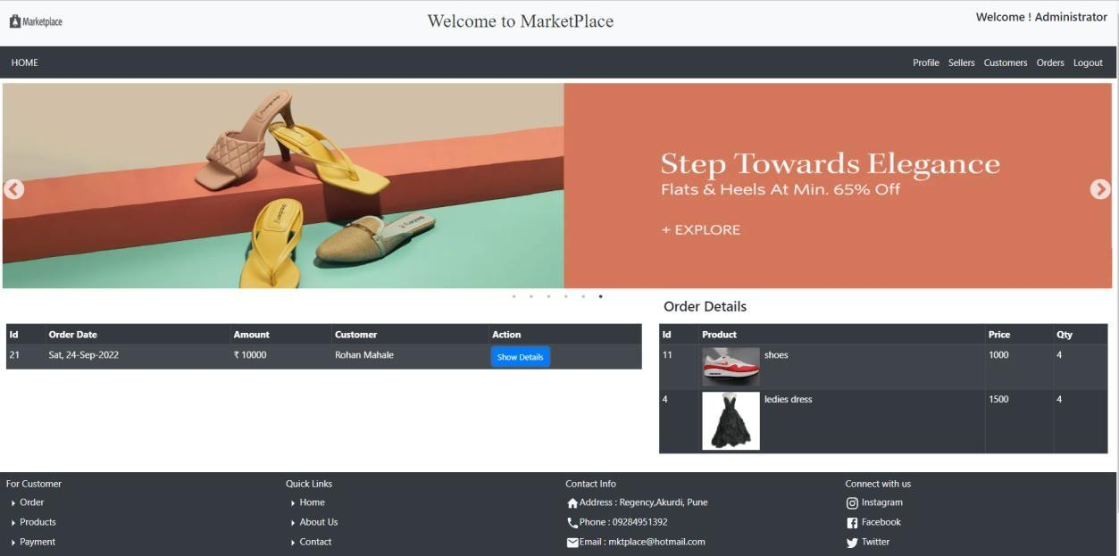

# CONCLUSION

The project entitled E-Commerce (Online Shopping Mart) was completed successfully.

The purpose of building this project has been achieved successfully and the system has been developed with much care and free of errors and at the same time it is efficient and less time consuming The purpose of this project was to develop a web application for selling and purchasing items from a shop using E-Commerce e-commerce website. This project helped us in gaining valuable information and practical knowledge on several topics like designing web pages using React.js, usage of responsive templates, designing REST API, and management of database using MySQL. The entire system is secured. Also, the project helped us understanding about the development phases of a project and software development life cycle. We learned how to test different features of a project.

This project has given us great satisfaction in having designed an application which can be implemented to any nearby shops or branded shops selling various kinds of products by simple modifications.

There is a scope for further development in our project to a great extent. A number of features can be added to this system in future as online websites now provide detailed descriptions of their products so that the customers have a clear idea. Many websites also provide feedbacks that other users have given. This helps in assuring other prospective customers. It also makes payment easier since it can be easily done online. The scope of E-COMMERCE looks like it will be increasing for a long time. We have seen online businesses grow with globalization as it facilitated the easy shipping of products all over the world.

# REFERENCES

1. <https://drive.google.com/drive/folders/1K6NU3A64GvhG3xS05KAL_3pdH8Gq66io>
2. <https://aws.amazon.com/solutions/case-studies/amazon/>
3. <https://www.storegrowers.com/google-shopping-case-studies>
4. Mc Graw Hill’s, Java: The complete reference 7thEdition, HerbertScheldt
5. <https://www.geeksforgeeks.org/web-development-projects/>

###### ONLINE REFERENCE

1. [www.Google.com](http://www.google.com/)
2. [www.w3school.com](http://www.w3school.com/)

[1] [www.javatpoint.com](http://www.javatpoint.com/)